The New England Regional Airport System Plan

Helping New England Be New England

Sponsored by the New England Airport Coalition

- Bangor International Airport
- Boston Logan International Airport
- Bradley International Airport
- Burlington International Airport
- L. G. Hanscom Field
- Manchester - Boston Regional Airport
- Portland International Jetport
- Portsmouth International Airport
- T. F. Green Airport
- Tweed-New Haven Regional Airport
- Worcester Regional Airport

- Connecticut Department of Transportation
  - Bureau of Aviation & Ports
- Maine Department of Transportation
  - Passenger Transportation Division
- Massachusetts Aeronautics Commission
- Massachusetts Port Authority
- New Hampshire Department of Transportation
  - Bureau of Aeronautics
- Rhode Island Airport Corporation
- Vermont Agency of Transportation
  - Aviation Program

- FAA Airports Division

- New England Council

Inside...

How Does Aviation Help New England Be New England?  New Englanders fly a rate 80 percent higher than the national average. Knowing why helps us understand the essence of our region and how air transportation helps to preserve it. | 4
Understanding Regional Airport System Dynamics  Understanding regional airport system dynamics begins with understanding the evolving nature of the airline industry and its interaction with airport development. | 7
Building the Forecasts - The Basic Logic and Assumptions  Forecasts are more than numbers; here’s a brief primer on developing a critical eye for interpreting the products of the forecasting models. | 14
Forecast Results  What they tell us about the nature of the air transportation services required by the next generation of air passengers. | 18
Challenges for the Regional System  This presents a strategic approach to providing an essential public service that relies upon a constantly evolving private airline industry. | 27
Meet the Airports  A summary of key facts and issues for each of the study’s airports. | 34
- Bangor International Airport | 34
- Boston Logan International Airport | 36
- Bradley International Airport | 38
- Burlington International Airport | 40
- L.G. Hanscom Field | 42
- Manchester Boston Regional Airport | 44
- Portland International Jetport | 46
- Portsmouth International Airport | 48
- T.F. Green Airport | 50
- Tweed-New Haven Regional Airport | 52
- Worcester Regional Airport | 54
Finally…  Some final thoughts on the commitment required to achieving this vision and an acknowledgement of the organizations and individuals who contributed to this effort. | 56

Introduction

In the early nineties, the New England Region was faced with a dilemma that threatened its future economic development and vitality. In a world that was increasingly dependent upon air transportation, New England’s primary airport, Boston Logan International Airport, was running out of capacity and efforts to land bank a site for a new major airport had failed.

In the best Yankee tradition, the region began to examine how to make the best use of the resources they had - a system of under-utilized regional airports. By the end of the decade a unique collaborative effort involving all six state aviation agencies and eleven passenger service airports had positioned the regional airports to benefit from the entry of low fare carriers and had improved access to airline services for passengers throughout New England. However, the question remained, “Will this be enough to provide for the needs of the next generation of air passengers?”

To answer this question this coalition sponsored the New England Region Airport System Study (NERASP). This study discovered some very interesting answers to this central question. First, the region has an unusually high reliance on air transportation. Second, the system does have the ability to meet passenger demand through 2020. But to do so requires continued efforts to enhance the performance of each airport in the system. This is essential to achieve the level of efficiency and resiliency the system must have for a region so dependent on the services of a constantly evolving airline industry.

A majority of the Region’s passengers will continue to fly through Boston Logan International Airport. Therefore, the system will rely upon Logan to continue to improve its efficiency in handling aircraft operations and passengers. This study also identifies several airports that could improve the performance of the regional system if they can overcome the challenges they face in developing the services required by their communities. For example, Providence’s T. F. Green Airport lacks sufficient runway length to efficiently serve its communities’ needs for west coast and international markets. Worcester and New Haven have the potential to serve a total of 3.8 million passengers, drawing almost one million of these passengers away from congested airports in New England and New York. The forecast models also reveal an emerging market for jet service from Cape Cod to major domestic markets.

This report describes the foundations of a regional strategy for the air carrier airport system to support the needs of air passengers through 2020. Its underlying theme is to develop an airport system based upon the location of passengers and with adequate facilities to allow airlines to evolve the range of services that provide the best mix of efficiency, convenience, and reliability.

By providing this forward vision of the region’s needs, this study hopes to promote a common understanding of the challenges that need to be addressed by local airport planning and development programs.

A message from the Administrator of the Federal Aviation Administration (FAA)

New England continues to lead the way with an effort that is marked by both ingenuity and conservation of valuable resources. The New England Regional Airport System Plan is a blueprint that will be of great benefit to the passenger service airports in the great northeast.

This project represents an unparalleled collaboration by the six New England state aviation agencies and their passenger jet service airports. This plan combines the best and the brightest from academia, industry and government.

What you’ll find is a shared understanding of the challenges and opportunities presented to New England’s airport system. This document provides our airport managers and their governmental sponsors with a clearer view of the action required to support the air transportation needs of their communities. This means that significant investments can be made with an understanding of the long-term needs of the region’s passengers. More to the point, this plan is not influenced by the ups and
downs of the airline industry.

The value of applying regional planning for preparing for tomorrow’s challenges to our aviation system is of such national importance that I have made the completion of this study part of FAA’s Flight Plan.

Marion C. Blakey
Federal Aviation Administration

A Message from FAA’s New England Regional Administrator

In less than ten years, the United States will reach one billion passengers annually. The emergence of very light jets, the move from wide-body aircraft to smaller jets, and the shift to new entrants are changing the way Americans travel by air. It is an exciting future for the aviation industry.

The New England Regional Airport System Plan represents a key step in preparing for the future. It combines regional planning, economic development, and insightful knowledge of the air carrier industry to create a superb decision resource for the future development of the 11 passenger jet airports in the region. It will provide invaluable guidance for airport operators as they make important facility development decisions. In addition, it will support the regional coordination among airports required to serve the unique air transportation needs of the New England region.

If aviation is the lifeblood of America’s economy, and our airport system is the heartbeat that makes it go, this is doubly true for New England. There are challenges ahead. The New England Regional Airport System Plan inspires confidence that we will be ready to meet them.

Amy L. Corbett
Regional Administrator
FAA New England Region
A Message from this Study’s Sponsoring Agencies and Airports

The coalition of the region’s major airports, the six New England state aviation agencies, and the Federal Aviation Administration are proud of our latest effort the New England Regional Airport System Plan to understand the air transportation needs of New England.

Our coalition was established in the early ‘90s to develop a continuous approach to monitoring and managing the progress and
challenges of our New England airport system. We found that the development of this information at the system level gives us greater confidence as we strive to support the policies and investments required for the continued growth and prosperity of each of our jurisdictions within the New England region.

- Bangor International Airport
- Boston Logan International Airport
- Bradley International Airport
- Burlington International Airport
- L.G. Hanscom Field
- Manchester Boston Region Airport
- Portland International Jetport
- Portsmouth International Airport
- T. F. Green Airport
- Tweed-New Haven Regional Airport
- Worcester Regional Airport

- Connecticut Department of Transportation
- Maine Department of Transportation
- Massachusetts Aeronautics Commission
- Massachusetts Port Authority
- New Hampshire Department of Transportation
- Rhode Island Airport Corporation
- Vermont Agency of Transportation
Message from the Manager, FAA New England Region Airports Division

Normally our Division’s role is to provide funding and technical review to studies performed by the airports and state aviation agencies. For the past 12 years, however, the New England Region has enjoyed a true collaboration with this coalition. This partnership has allowed us to produce the quality of information that has successfully guided the investments leading to a stronger regional airport system. I want to take this opportunity to thank all the participants for the spirit of trust and cooperation that has been a defining element of our regional programs.

A high level of effort was directed at producing a report that would be informative to interested members of the public who do not have extensive aviation backgrounds. I hope all readers find that they have gained a deeper insight into the issues that will be engaging those of us working individually and collectively to meet the needs of New England’s next generation of air passengers.

And, finally, I would like to express my appreciation and admiration for the consultant and agency staff directly involved in producing this report. They have provided us with a product that not only advances the needs for our region, but also advances the very practice of regional airport system planning itself.

Laverne Reid
Manager,
FAA New England Airports Division
How Does Aviation Help New England Be New England?

Introduction

New England has an unusually high reliance on air transportation. The region generates 2.5 air passenger trips per year per capita, almost 80 percent higher than the national rate of 1.4. While this is a remarkable fact, a closer look reveals that several of the essential attributes of New England offer a plausible explanation for this high level of air travel. These attributes can be grouped into four categories geography, economy, population and cultural and scenic resources. Taken together they portray the very essence of New England. And underlying this portrait is a vision of the critical role
of high quality air transportation in sustaining the variety of attributes that combine to sustain this essence. Let’s take a closer look at these.

Geography Economy Population Resources

The factor that weaves these attributes together is air transportation.

Geography

New England’s location in the northeast corner of the country tends to turn New Englanders toward air travel. While high-speed rail offers a good alternative to New York, Philadelphia and Washington, business travelers have few alternatives
to air beyond this range. For most trips to other parts of the country, the convenience and speed of air travel is compelling. And with the emergence of low fare service, an increasing percentage of New England-based leisure travelers
have come to prefer air travel as well.

Economy

Some economists believe that economic growth will flow toward areas with a critical mass of people who are creative, enterprising, and collaborative. (See Footnote 1) This “creative class,” scientists, engineers, academics, doctors, and media professionals, seek to locate in places that exhibit certain qualities. These include an appreciation of individual merit, a tolerant social environment, an academic atmosphere, and opportunities to participate in active, outdoor recreational pursuits. New England fits this profile in a number of ways: the number of educational institutions, the culturally and ethnically diverse cities, the heritage of independent thinking, and easy access to a wide range of recreational experiences. As just one example of the existence of this type of economy in New England, the percentage of New England’s jobs in the medical, educational, and “information” fields is nearly 20 percent - as compared to just under 15 percent for the country as a whole. (See Footnote 2)

While advances in telecommunications and information technology have substituted to some degree for face-to-face communication, there still is a tremendous reliance on travel among participants in the knowledge industries. And the region’s acknowledged national leadership in education and medicine also tend to support the use of air travel. Researchers, medical professionals, patients, faculty, students, and conference participants travel to and from New England in great numbers and they do it by air.

Finally, international markets are increasing in importance for the New England economy. This is especially true of the rapidly developing Asian economies which are expanding in sectors (high technology, communications, etc.) that are of
relevance to New England’s own economy. The correspondence between these economies naturally contributes to the region’s high rate of business air travel.

Population

Income and education levels that are well above the national average characterize the region’s population. The 2000 U.S. Census indicates that two of the 5 most affluent states are Massachusetts and Connecticut. These higher incomes support higher levels of leisure air travel. This has been further stimulated by the expansion of low fare airlines throughout the New England market. And it is yet to be determined the extent to which leisure travel will grow, as baby boomers enter retirement with higher levels of disposable income and greater inclinations to travel than previous generations.

The degree to which the New England economy relies on its airports can be seen by considering a few other facts: in 2004, over 45 million people traveled by air from a New England airport to destinations in all 50 states and numerous countries. Over 700 metric tons of cargo - from electronic components and fresh flowers to tuna and maple syrup - was transported by aircraft from Logan Airport.

Airports are also a very important center of business activity in the region. It is estimated that the combined impact of revenues and payrolls generated by the NERASP airports exceeds 13 billion dollars per year.

Scenic and Cultural Resources

It has been said that had the United States been settled from West to East, all of New England would today be a national park. While that may be debatable, what is less debatable is the touchstone of the New England regional identity. The New England landscape is alive with spectacle, variety, and compelling natural beauty. It speaks to all of us: natives, long-time residents and even the college students who come, graduate and decide to stick around awhile. A natural magnet for tourism, the New England landscape is a human-scale panorama. It extends from the embrace of the Housatonic Valley to the hilly sanctuaries of the Berkshires; from the lakes of Central Massachusetts to the Maine coast; from the salt marshes of Cape Cod to Vermont’s Mount Mansfield; and from the kettle ponds of Rhode Island’s South County to the majestic Presidential Range of New Hampshire. There are few geographic brands as successful as “made in New England,” whether the product being sold is fall foliage, ski vacations, striper fishing, or maple syrup. Of course, the ultimate New England “product” is much of our national heritage; this includes, for example, pilgrims’ landings, sea trading, whaling, ship building, and the first shots fired in the war for independence. These qualities make New England a popular destination for travelers from throughout the country and abroad, and they travel here overwhelmingly by air.

Summary

The special attributes discussed above - involving geography, economy, population and resources - are essential ingredients in the formation of the New England identity. And these attributes tend to support one another. For example, the cultural and
scenic qualities of the region are one of the “qualities” that attract “creative class" industries; and the existence of these industries produces a population with higher levels of income and education. And the factor that weaves these attributes together is air transportation. It provides the ready two-way access between New England and the national and international markets essential for the function of the region's economy and the lifestyle of its population.

It was recognition of this reliance of New England on air transportation services that forged the alliance of the region's state aviation agencies and major airports, and motivated them to undertake this study. Given this understanding of why New Englander's fly 80 percent more frequently than the national rate, it is essential to have a strategy for developing an airport system that supports the aspirations of the region’s population and industries. This report describes both the analytical underpinnings and the specific actions comprising such a strategy for ensuring the vitality of the regional airport system through the next twenty years.

An example of how New England leads in knowledge industries is demonstrated by its role in medical training. Nearly 10 percent of the 375 member institutions of the (COTH), which represents the best hospitals in the country, are located
in New England. Massachusetts alone, the cornerstone of the New England medical sector, is home to 16 COTH member institutions, nearly one-half the New England total.

New England's regional airports have continued to evolve into a true system, a system in which increasingly overlapping service areas and improved ground access options are providing passengers with real options as they make air travel decisions.

Understanding Regional Airport System Dynamics
Scheduled Passenger Jet Service Airports

The New England Regional Airport System Plan (NERASP) study is the latest effort in an ongoing program of regional planning that began around 1990. (See Footnote 3) New England's commitment to regional airport planning arose from two related concerns.

First, Logan Airport in Boston, the region's busiest airport, was becoming increasingly congested and efforts to either expand capacity or develop a second major airport were judged impractical. (See Sidebar "How About a Second Major Airport in New England?")

Second, there was a growing awareness that several under-utilized airports were within easy reach of the Boston region and were capable of supporting jet service to major destinations outside New England. Many of these had just completed facility projects in response to development of new airline services following deregulation only to find passengers drawn back to Logan by airline price wars. In response to an initiative begun by the New England Council, the New England region formed a coalition of its scheduled jet service airports, the state aviation agencies, and the Federal Aviation Administration began to develop a plan for enhancing airline services throughout the region. (See Footnote 4)

This effort to improve the development of regional airport services had the following three objectives:

1. Improve customer service - match air travel service to passengers’ needs.
2. Support the region’s economy - ensure an efficient and reliable system of air service development consistent with the region’s growth.
3. Provide an environmentally sound air service system - minimize total distance traveled to access air travel, reduce passenger demand at congested airports, and avoid the need for developing a new major air passenger airport in New England.

Understanding regional airport system dynamics begins with understanding the evolving nature of the airline industry and its interaction with airport development

The Dynamics of the Regional Airport System

The behavior of this region’s airport system has primarily resulted from the interaction of airline services with the distribution of demand for airline services across the region. (See Footnote 5) By increasing their understanding of both the nature of passenger needs and the business strategies of the airlines, the public agencies in New England responsible for the airport system have substantially improved the distribution of air services for the region. This can be seen in the following review of major patterns of airline competitive strategies and consequent impacts on airport development since the deregulation of the airline industry.

Post-deregulation
(1982-1989)

In the early 1980s, just after airline deregulation, Logan served 78 percent of the region’s air passengers. Over the course of the decade, the development of hub and spoke systems by major airlines and aggressive airline expansion strategies introduced new jet services at regional airports and increased the use of connecting flights between Logan and regional airports with new turboprop aircraft. The regional airports invested in expanding passenger facilities and airfield improvements in reaction to rapid growth in passenger activity. By 1989, Logan’s share of the market had declined to 68 percent.

Competition for market share in major markets
(1990-1995)

The early 1990s ushered in a period of economic decline. In response to operating deficits, airlines shifted towards a business strategy of market dominance in major markets. This led to fare wars at Logan and premium fares at regional airports. Growth at regional airports was stagnant. Some airports were financially strained by recently expanded, but under-utilized facilities. In an effort to create more system balance and to support regional economic expansion, a coalition of airport sponsors and aviation agencies was formed to promote the development of air transportation service
throughout the region. The first action was to conduct a study of the geographical distribution of air passenger
markets across the region. The purpose of this was to evaluate the opportunity for improved jet services at the regional airports.

Armed with this study, in 1996, this coalition launched
its “Fly New England” campaign. It included:

- A regional conference with all of the airlines to introduce the study findings,
- Collaborative marketing campaigns to improve passengers’ and travel agents’ awareness of regional airports,
- Use of the study data by airport managers to demonstrate to airlines the opportunities for enhancing revenues through lowered fares and improved routes, and
- Funding of key runway and facility improvements to support regional airport markets.

Entry of low fare airlines and growth of regional airports
(1996-2000)

Coincident with the efforts of the “Fly New England” campaign, Southwest Airlines decided to expand into the New England market through the region’s secondary airports rather than Logan, expanding first at Providence and then into Manchester and Bradley. This was a significant catalyst to regional demand as their entry was met with both service improvements and fare reductions by the existing airlines.

This led to a complete reversal of the pattern of passenger growth over the first half of the decade (See Figure #1). From 1990-1996, Logan accommodated 77 percent of the 2.9 million passenger increase in New England. Over the next three years, when the region’s air passengers increased by 6.3 million, the regional airports accommodated three-fourths of the region’s growth. During this same period, new terminal and parking facilities were completed at Bradley, major runway extensions and terminal improvements were built at Manchester, and T.F. Green expanded terminal facilities and access road capacity. Logan completed a major modernization of its terminal and circulatory roadway system. Meanwhile Logan embarked on a major planning and environmental study to find ways to improve its airfield in order to continue serving the core Boston
metropolitan market.

Figure 1
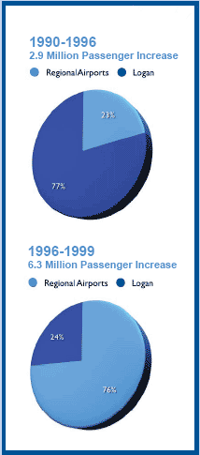

Post recession and terrorism
(2001-2005)

Clearly, the terrorist attacks of September 11, 2001, caused an unprecedented and immediate decline in air passenger activity. Logan was already experiencing reduced activity due to the shake-up of the “dot-com” and financial sectors and the resulting decline in business travel. This was a period of tremendous financial crisis It led to financial restructuring, a drastic reduction in the number of aircraft being flown, and a growing effort to emulate low fare carriers. Airlines pulled out of smaller markets such as Worcester. Despite these conditions, the other regional airports demonstrated a solid market that recovered much more quickly. In fact, from 2001 through 2005 Manchester maintained positive year to year growth.

However, as financial difficulties from multiple fronts continued to undercut the profits of the large network carriers, they have once again concentrated their downsized fleets in the largest airport markets. Logan and its significant passenger base has benefited. Logan now has low fare service to an extensive national network and airports such as Manchester are experiencing declining activity due to service reductions by the network carriers. (See Footnote 6)

Lessons Learned

And so we see that the past 20-plus years of air travel have featured dramatic fluctuations. These have included the creation of hub and spokes services following deregulation to a period of market dominance and fare wars in the larger market airports to the growth of the regional airports to the current post-9/11 environment. This has led to a number of useful findings and observations. They are as follows:

Major Drivers

- Airline competitive strategies are constantly evolving and have significant impact on levels of activity at airports.
- The growth in demand for air travel, the improvements in cost efficiency of new aircraft and the emergence of new airlines will continue to drive innovation in airline business strategies.
- Given the previous two conditions, airport planning that bases its decisions on current airline service strategies will likely be in error. Developing airport facilities must be based on a longer-term understanding of passenger needs.

Specific Regional Dynamics

- Manchester and Providence have similar relationships with Logan in that they function as alternative bases for airlines that compete for passengers from the greater Boston metropolitan area. Airlines prefer to match services from both airports. Inadequate facilities in one location can impede service development at both.
- The leakage rates and new service opportunities estimated in the mid nineties were a strong predictor of where passenger growth occurred in the late nineties. (See Footnote 7) This is an initial confirmation of the validity of the analytical approaches being used in these studies.
- During periods of consolidation of airline services, airports dominated by low-fare carriers may lose service more rapidly
since the network carriers will be targeting their services toward markets with higher profit margins.

Tactical Lessons

- There are unpredictable and significant shifts in levels of passenger activity. Financial plans for facility investments must be able to withstand fluctuations in revenue.
- A new entrant airline at Worcester and Portsmouth, Allegiant Air, purchased baggage handling and ramp services from local aviation service companies. Though this airline has since left Worcester, it may still serve as a business model that could allow other airlines to enter these markets without having to commit to the overhead of staffing a new station.
- Passengers are averse to lengthy and unpredictable delays in all segments of their air travel since it requires starting a journey with an extra margin of time that will most often be perceived as wasted waiting in an airport terminal. If an airport can demonstrate greater reliability and predictability of all portions of the air trip, they may be able to significantly influence the passengers’ choice of airports.

High Speed Rail

- During the initial period following 9/11, there was an increase in passengers using Amtrak service to the New York City area. Unfortunately, equipment problems interrupted this shift in mode choice. Nonetheless, Amtrak rail service demonstrated its value as a complement and back up to air service for this segment of the Northeast Corridor. Of course, neither mode is a perfect substitute for the other. Public investments need to evaluate each system on terms of its own primary passenger base and consider their ability to complement each other as an additional and highly desirable public benefit.
History of Regional Planning in the New England Region

1989

Massachusetts System Plan identified the need to land bank a site for a second major airport as Logan was forecasted to reach capacity by 2010.

1990

Massachusetts initiated a site selection study for a second major airport.

1993

The Massachusetts Strategic Assessment Report identified that a greater use of regional airports combined with airfield improvements at Logan and high-speed rail service to New native to a new major airport.

1994

A coalition of six New England State Aviation Agencies, all of the scheduled jet passenger service airports, and the New England Council was formed and initiated the "New England Regional Air Service Study."

1996

The regional coalition held a “Fly New England” workshop with airline representatives to present the findings of this study and to outline collaborative marketing programs.

1998

Phase II of the regional air service study provided updated data on air service opportunities in the region.

2002

Phase I of the New England Regional Airport System Plan (NERASP) was initiated.

2004

Start of Phase II of the NERAP study.

Looking Ahead

The last 20 years have demonstrated that the airline industry is volatile. It shows that a regional strategy is needed; one that has both the flexibility to accommodate the need of the airlines to operate efficiently and an understanding of long-term market forces. New England’s regional airports have continued to evolve into a true system, a system in which increasingly overlapping service areas and improved ground access options are providing passengers with real options as they make air travel decisions. It has benefited by combining an understanding of the long term needs of passengers with an appreciation
for the financial risks in the air transportation industry and the interaction among our airport markets. Looking ahead it is vital that, while each airport plans its own development program, we maintain at the same time a shared vision of how the New England Airport System can function in a way that provides optimal air transportation services to serve the region’s future.

This Report

The rest of this report presents the building blocks upon which this shared vision can be developed. These are organized around the following questions:

- How were the forecasts developed, what are the critical assumptions and how do they deal with the uncertainties of the air transportation marketplace?
- What do we know about future passenger needs?
- What are the challenges and key objectives in developing a regional system to respond to those needs?

More detailed information is provided in the two-page presentation of data for each airport. Finally, all of the technical papers developed during the course of this study have been compiled on a CD (see back cover for ordering information).

How about a Second Major Airport in New England?

Typically, whenever a major airport such as Logan is facing increased congestion and lacks the opportunity to expand, there arises the question of building a new airport to solve the problem.

Peter Meade was the President of the New England Council in the early nineties. The Council had studied the problems at Logan and concluded in 1989 that there was a need to begin developing a Second Major Airport in Massachusetts. When Fort Devens was closed as an active military base there were ongoing studies considering developing it into a major commercial airport. Mr. Meade relates the following discussion of the region’s congressional delegation on this issue.

When I told the Senator that we would like his support for redeveloping the base as a new major airport he looked at me and said, “Before you came in I was meeting with a group that wanted a federal prison in order to keep out the airport, and before that there was a group that preferred a trucking terminal. And after I meet with you I have an appointment with a group willing to consider a nuclear waste disposal site to prevent an airport being developed! Now what do you think the chances are that you can get sufficient popular support behind using the base for an airport?”

Swallowing that dose of reality, Peter Meade began a discussion with airport officials and the FAA about how the region could function without a new airport. From these efforts, grew the six state consortium of aviation agencies and
airports that launched the “Fly New England” project and this latest study.

ln(RP) = C + CY*ln(Y) + CPCIP*ln(PCIP) + CPP*ln(PP) + CLFC*LFC + CREC*REC

Building the Forecasts-

The Basic Logic and Assumptions

Predicting how scheduled air services would change and how those changes would impact the region’s airport system presented a major challenge to the study. One reason for this is that the models used needed to (a) be sensitive to the factors influencing passenger demand and (b) produce estimates of various trip destinations and types of passenger at reasonable levels of detail. The need for forecasts of other activities at the region’s 11 jet passenger airports, such as scheduled cargo and general aviation activities, presented a further challenge. However, the primary focus of this study was scheduled passenger markets for domestic routes, as this activity has the greatest impact on the overall functioning of the regional airport system.

Three Questions - Three Models

In an effort to understand future patterns of domestic passenger activity, the following three major questions presented themselves:

- What is the magnitude of air passenger travel demand between New England and other major destinations in the United States (the macro demand model)?
- Where in New England do passengers ultimately begin and end their trips (the passenger allocation model)?
- What would be the pattern of passenger airport selection in response to changes in schedules, fares and the time required to get to airports (the airport choice model)?

How Many Passengers?

To answer the first question, past travel patterns were used to create a forecast model that compared air travel behavior in three New England “submarkets” to 62 domestic markets around the U.S. The three submarkets were given the names Central, North/West, and Southwest. Working with 20 years of historical value, the study team spent considerable effort to find forecast formulas that provided both a good statistical fit and made common sense. Statistical fit is simply looking back and measuring how well year-to-year changes in key factors, say population and air fares, predicted the number of passengers who flew. Common sense is then applied to ensure that the mathematical formulas that come out of the efforts to find a statistical fit represent our understanding of the basic laws of markets. For example, as prices fall, consumers will usually buy more of a product. Based upon this work, it was determined that the three most important factors affecting increased demand for air travel are increases in population, increases in personal income, and decreases in airfares. (See Footnote 8) Developing separate forecast equations for short, medium, and long distance markets further refined the forecast. Using forecasts of population and income obtained from www.economy.com and predictions of future airfares from a review of FAA and industry forecasts, an overall “macro” forecast of demand was developed that applied these three factors to each of the 62 major domestic markets.

Forecast Scenarios

Every forecast reflects underlying assumptions. These are forecasts in and of themselves of how certain market conditions will change in the future. To address natural uncertainty in the forecasts of these market conditions, it is common to construct “scenarios” reflecting changes in these market conditions. By looking at the effect of variations in those scenarios, we can get an idea how sensitive the forecasts are to changes in underlying market conditions.

In order to identify which scenarios would be of greatest value to this project, a two-day workshop was held with study participants - agency staff, consultants, and peer group members. The workshop focused on evaluating how future demand for air travel could be affected by a variety of departures from historical trends. These departures, called “trend-breakers,” can range from geo-political issues to changes in aircraft technology and telecommunications. After a careful analysis, it was determined that, the bottom line impact of these large but unpredictable events could be simulated by changes in the major drivers of passenger demand - growth in income and changes in airfares. Based on this, the first scenario represented a continuation of current trends in those drivers. This is called the Base Case. In addition, two alternative scenarios were tested: one leading to a higher forecast and one leading to a lower one.
In the higher scenario, called the Enhanced Scenario, the per capita income growth rate was increased from 1.6% to 2.4%. Airfares were allowed to decline in a manner similar to the base case assumptions with the exception of Boston and the NYC area airports, where it was assumed that high passenger volumes and associated congestion would result in premium pricing, driving average airfares up by 15%. In the lower scenario, called the Depressed Scenario, the annual increase in per capita income was lowered from the 1.6% to 0.8% and airfares were held at current levels. This approach also
allowed us to measure the sensitivity of the forecast to these two drivers of demand.

Adjustments to “Passenger Forecasts”

The method used to develop the forecasts of passenger activity between New England and major domestic markets produced a successful result as defined by its ability to replicate how historically passenger demand changed in reaction to changes in
income, population, and fares. But as one member of our Peer Review Panel is fond of saying, these methods “are like trying to drive down the highway by using your rear view mirror.” (See Footnote 9) In a review of the initial forecasts, it was noted that the historical period used for model calibration was coincident with a declining price of air travel and an expansion of services. It was further determined that this caused the model to produce average annual growth rates that exceeded longer-term historic experience and that such growth was not sustainable into the future period covered by this study.

Since we already had developed an enhanced scenario to help us understand the impacts of higher-than-anticipated growth, professional judgment was used to modify the model’s base case forecast to reflect a more reasonable growth rate of
2.3% that reduced the 2020 forecast from its original 92.8 to 75 million passengers.

What are the Places of Origin of the Passengers?

To answer the second question: concerning where passengers ultimately begin and end their trips, the study conducted simultaneous surveys of passengers at all airports with scheduled airline service. The content of these surveys permitted the data that was collected to be broken down into resident vs. non-resident travelers and business vs. leisure travelers.

An important product of the survey was a profile of passengers that, when combined with demographic data from cities and towns throughout the region, enabled the study to estimate passenger origins by municipality within major markets as well as
groups of communities in more rural areas.

Which Airports Will Passengers Use?

Finally, the third question was addressed using the Airport Choice model. Using the data gathered in the 2004 passenger survey, the study created a model to predict airport choices by passengers. It simulated the frequency of passenger choice of a given airport based upon ground travel times, the availability of non-stop air service, and fares. This model was then applied to estimate the volume of demand that each regional airport would be capable of sustaining. In the process, the
model reflected consideration of the minimum market size needed to support airline service in particular markets. The model not only estimated the volume of passengers expected to use one of the 11 airports but also it identified the new types
of markets that a given airport might expect to be able be serve in the future.

There is one assumption contained in the airport choice model that deserves special mention here. The underlying mathematics used to create the model try to use available information about fares, non-stop routes, and travel times to airports to
explain how passengers used airports at the time of the 2004 survey. What can’t be explained by those factors is lumped into a unique airport constant for each airport. Except for the experiments with unconstrained forecasts of Worcester and New
Haven, this study generally held these factors constant through time. It may require subsequent surveys to determine whether there is a need and a basis for revising these airport factors to significantly improve our forecasts and understanding of future passenger needs.

Intra-regional and International Passengers, Air Cargo, and General Aviation

The major focus of this study was air passenger service to domestic markets. But in order to understand the ability of the airports to accommodate this demand it was necessary to also forecast the full range of activities that could be expected at these airports. These are as follows:

Intra-regional passengers include passengers traveling between cities in New England. In this study, New York City airports were also viewed as intra-regional trips. International travel involves both trans-oceanic flights as well as Canadian and
Caribbean destinations. While Boston’s Logan Airport remains the dominant international airport for the region, services to these closer markets are developing at airports throughout the New England system. Air charter flights are common within this market.

Air cargo services have an essential role in the region’s economy. Air cargo travels as air freight forwarded in the cargo bays of scheduled passenger flights as well as shipments in dedicated all-cargo aircraft.

General Aviation (GA) refers to non-scheduled flights. The most common form of GA is the privately owned single-engine aircraft. However this is a very diverse market and at larger airports, GA operations may be dominated by twin turboprop engine, helicopter and jet aircraft.

Trend analysis was used in developing the forecasts for these additional segments of airport activity. This approach involved the use of a comparative analysis of past growth at each airport as a share of national growth, along with assessments of local developments that could have an impact on the local share of national and regional markets. In addition, national forecasts by the FAA and industry analysts were evaluated and used, as appropriate, to refine our estimates of growth at each of the NERASP airports.

Expanding Expertise Through Peer Review Panels

The forecast models were developed with the assistance of a panel of academic experts in aviation and market analysis. Similarly, a panel of economists reviewed our economic forecasts. While the quality of these forecasts remains the responsibility of the consultant team, both of these panels made significant contributions to improving the forecasts presented in this study. (See Footnote 10)

Forecasts: A Sketch Not A Photograph

Forecasts of air passenger activity should be applied to practical contemporary issues with a considerable amount of judgment. Not only is there significant variation in year-to-year activity but the nature of air travel and how it fits into the lifestyles and work habits of passengers is also constantly evolving. Therefore these estimates should not be considered to be a sharply focused photograph with accurate depiction of small details, but a well-studied sketch of the character of the future, best viewed at a little distance to properly perceive the impression it creates.

Forecast Results

Overall Growth

The New England Region experienced a total decline in passengers from 2000 to 2004 but is forecast in the Base Case Scenario to 75 million passengers by 2020. International activity is shown to grow most quickly by an average annual rate of 4.7% over the next decade (2010-2020).

New England Passenger Forecast

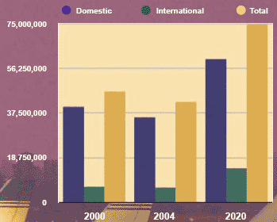

Forecast Scenarios

As explained in the Forecast Methodology, forecast scenarios were developed to help determine how air passenger demand might change under varying economic conditions, for example, if the economy were to grow either more slowly or faster than expected. The economic and fare assumptions that define the scenarios are shown in the following table.

One interesting observation that emerged from the analysis of the scenarios concerns the sensitivity of passenger demand to changes in future income growth. The assumption for growth in personal income in the high and low growth scenarios was
adjusted 50 percent upward (from the Base Case) and 50 percent downward respectively. The resulting effect on demand was not symmetrical. For example, with an economy weaker than the base case, and all other factors held constant, air travel is
projected to decrease by 7.5 million passengers. But a 50 percent improvement in the economy creates a larger increase, of 15 million passengers.

Therefore, it is important that airport facilities maintain the ability to accommodate and quickly adjust to increases in demand in order to support cycles of economic expansion. This requires leading rather than reacting to passenger requirements. Investing for demand that is supported by an airport’s catchment area characteristics is different
from “build it and they will come” development. Alternately, flexibility for rapid expansion can often be incorporated into facility designs for a modest additional cost. Finally, the very nature of an airport system approach provides the flexibility to offset congestion at one location with surplus capacity in adjacent markets.

Forecast Scenarios
Base | Population  Real Personal Income | 0.3%  1.6% | CY 2004 Fares  -1.2% p.y. through 2020
Enhanced | Population  Real Personal Income | 0.3%  2.4% | Base Fares, with 15% premium at  BOS and NYC airports
Depressed | Population  Real Personal Income | 0.3%  0.8% | CY 2004 Fares, held constant

Point of Origin of Future Demand

After overall demand for the region was forecast, this was disaggregated by regional point of origin, how this demand would be distributed across the region.

Point of origin of future demand indicates the following:

- Boston metropolitan area is forecast to retain a dominant share of the growth in New England passengers.
- The two airport catchment areas closest to Boston, Providence and Manchester, indicate strong growth in passenger demand.
- New Haven and Worcester both have substantial growth in their catchment areas yet have had difficulty sustaining service.
- Bradley continues to have a strong market.
- Portland’s market is forecast to increase at an average annual rate of 3.4%, though this could be expanded by the recent introduction of a low fare carrier, Jet Blue, into this market.
- Bangor and Burlington’s catchment areas are forecast to grow by 3.6% and 3.8% respectively, which are both higher than the overall regional growth rate of 3.5%

Catchment Area Forecasts

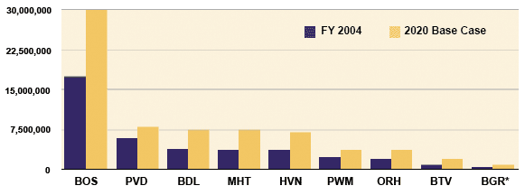

*Note: BOS-Boston, PVD-Providence, BDL-Bradley, MHT-Manchester, NVN-New Haven, PWM-Portland, ORH-Worcester, BTV-Burlington, BGR-Bangor, BED-Bedford, PSM-Portsmouth.

Airport Forecasts

Based on the geographical distribution of ground origins of the region’s passenger demand as previously discussed, an airport choice model was developed to determine how that pattern of demand would be distributed among the region’s airports. This yielded two useful findings: (1) forecasts of passenger activity at each airport, and (2) an indication of the level of success of each airport in serving its catchment area demand (or, stated another way, preventing the phenomenon known as “leakage.” the following article).

The table below displays the forecast results for each of the airports and for each of the scenarios. In viewing this table, you will recall that, as discussed earlier in Forecast Methodology, the forecast figures in the table reflect passenger choice behavior as they are collectively influenced by fares, service, and distance, as reported in the
2004 survey.

Forecast Airport Passengers – 2020 – Depressed, Base, and Enhanced Scenarios

Airport | Actual  FY 04 | Depressed | 2020 Base | Enhanced | Average Annual Growth Depressed | Average Annual Growth Base | Average Annual Growth Enhanced
BOS | 24,477,000 | 38,302,000 | 42,437,000 | 49,578,000 | 2.8% | 3.4% | 4.4%
BDL | 6,472,000 | 9,655,000 | 10,284,000 | 12,430,000 | 2.5% | 2.9% | 4.0%
PVD | 5,253,000 | 8,551,000 | 9,057,000 | 11,195,000 | 3.0% | 3.4% | 4.7%
MHT | 3,783,000 | 6,317,000 | 7,123,000 | 9,221,000 | 3.2% | 3.9% | 5.5%
PWM | 1,265,000 | 2,089,000 | 2,347,000 | 2,781,000 | 3.1% | 3.8% | 4.9%
BTV | 1,169,000 | 1,989,000 | 2,148,000 | 2,523,000 | 3.3% | 3.8% | 4.8%
BGR | 445,000 | 776,000 | 833,000 | 971,000 | 3.4% | 3.9% | 4.8%
HVN | 43,000 | 629,000 | 962,000 | 1,113,000 | 17.7% | 20.7% | 21.8%
ORH |  |  | 284,000 | 536,000
BED | 26,000 | 37,000 | 451,000 | 790,000 | 2.2% | 18.9% | 23.0%
Total | 42,933,000 | 68,345,000 | 76,026,000 | 91,138,000 | 2.9% | 3.5% | 4.7%

Results for Portsmouth were not shown since it was determined that within the planning horizon of this study, Portsmouth is expected to be limited to a role of developing complementary niche airline services. While the development of those services is difficult to forecast, they have been shown to yield important system benefits, such as providing an alternate location for ramp overnight parking of aircraft, especially for air charter flights. The Portsmouth airport is analyzing the results of this study in hope that such opportunities can be more readily identified in the future. Portsmouth may also be a very suitable airport for air charters or other operators considering use of the new Airbus A380 aircraft.

Forecast Leakage Rates

In the Overview article, it was stated that an objective of regional airport planning in New England has been to improve customer service by providing convenient access to competitively priced airline services. One way to measure the performance of the system is to examine leakage rates, the number of passengers leaving an airport's catchment area to use an alternate airport because they are willing to travel a greater distance to get better fares, more convenient schedules or other tangible advantages.

The model results for the forecast base case and 2004 leakage rates are shown in the chart below. Note that in this case lowered numbers represent improvements. As can be expected, Boston has the lowest leakage rate because of its extensive schedule of services. What would be less expected is that Burlington, VT has the second lowest leakage rate. This can be explained by the remoteness of this market from alternative airports.

Also of interest is the finding that the forecasts predict only modest reduction in the leakage rates for Manchester and Providence over the forecast period. By contrast, from 1996-2004 these airports, along with Worcester increased their share of the Boston Area System from 12 percent to 28 percent.

Generally this chart demonstrates that, to the extent the models are correct, the emphasis through this planning period will be placed on developing the services necessary to keep pace with growth in each catchment area rather than to accommodate any
drastic shifts in airport usage patterns.

It is important to note the caveat used, “if the models are correct.” The two major requirements of an airport choice model are:
- a large amount of data, and
- a set of well-crafted assumptions.
Data, of course, is very expensive and it is often difficult to determine the extent to which passenger survey responses reflect their perceptions about their choices versus the facts. The degree to which passenger behavior can’t be explained by schedules, fares, and access times are accounted for through an “airport constant.” This essentially is a bias factor, which is fine except we don’t know very much about how stable these are over time. More than likely they will change as passengers learn more about their choices and experiences using alternate airports. Yet our current forecasts hold them constant through 2020. Accordingly, it is recommended that the 2004 passenger survey be repeated periodically in order to continue to refine our understanding of shifts in passenger preferences and how airport choice behavior will be influenced by these changes.

Airport Catchment Area Leakage Rate – Bose Case Forecasts

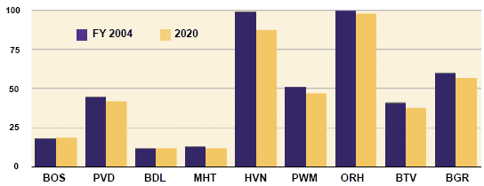

Comparison of Base Case to Unconstrained Forecasts

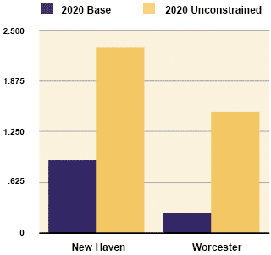

Unconstrained Forecasts for New Haven and Worcester

At the time of this study there was very little service at the New Haven and Worcester airports. In the original base case, forecast services for these two airports were built up gradually over time. In an experiment designed to examine the nature of their role in the regional system, the study allowed activity levels allocated to these airports to grow in a way that was not constrained by airport capacity (i.e., the physical ability of its facilities to handle traffic). To accomplish this, a more ambitious service schedule similar to that of Manchester and Portland was used to determine the degree to which higher level of services would attract passengers.

In addition, Worcester ground access times in the model were reduced to reflect improvements that were considered plausible in terms of actual projects. An adjustment was also made in the “airport constants” for these airports, as discussed above, to reflect those observed for Manchester and Portland. The results show that New Haven could potentially support 2.3 million passengers annually compared to 1 million in the base case and Worcester could potentially support 1.5 million compared to 0.3 million in the base case. In this experiment, leakage to the congested New York City and Logan airports is reduced by approximately 900,000 passengers.

Air Cargo

Air cargo, another important service provided by NERASP Airports most of the NERASP airports, was included in this study in order to address two critical questions:

- Does the regional airport system have the ability to provide the air cargo service the region requires?
- Will air cargo activity create any problems with development of these airports for scheduled passenger requirements?

The domestic cargo projections reflect:

- The projected moderate growth in the overall New England economy in comparison to other regions in North America.
- Increased truck substitution, particularly in the densely developed areas of New England and the adjacent regions in North America.
- A slight decline in cargo growth after 2010, reflecting more moderate economic growth in New England during the further years of the forecast period.

The international cargo projections reflect:

- A gradual economic recovery nationally and internationally, spurring increased global trade and more direct routes between New England and overseas markets.
- The projected moderate growth in the overall New England economy in comparison to other regions in North America.
- International cargo tonnage growth will be moderated by the continued substitution of ocean-borne cargo movements.
- Less leakage of international cargo from the New England region to John F. Kennedy International Airport.
- A slight decline in cargo growth after 2010, reflecting more moderate economic growth in New England during the out-years.

Airport-Specific Cargo Forecasts

An analysis was performed, using knowledge of both the strength of the market and the capacity of facilities at each airport. That analysis resulted in the following airport specific forecasts.

Projected Annual Growth Rates for Air Cargo NERASP Airports

Airport | 2005-2010 | 2010-2025
Logan | 3.0% | 3.0%
T.F. Green | 3.0% | 2.5%
Portsmouth | 0.0% | *
Portland | 4.0% | 4.0%
Burlington | 3.0% | 3.0%
Manchester | 6.0% | 5.5%
Tweed-New Haven | 0.0% | 0.0%
Bradley | 6.0% | 5.5%
Worcester | 0.0% | 0.0%
Bangor | 1.0% | 1.0%
* Note: New air cargo service potentially starts at airport if space becomes constrained at Manchester

New England Cargo Base Forecast Growth Rate Annual Projections (in tons)

Year | Domestic Cargo Growth | International Cargo Growth
2005-2010 | 3.0% | 3.5%
2010-2025 | 2.5% | 3.0%

General Aviation

General aviation (GA) includes all aircraft not operating as scheduled service or military operations. Its most common form is the single engine piston aircraft owned by an individual or club and used primarily for recreational transportation. Typically, as passenger airports develop more scheduled activity, these smaller aircraft will tend to find operating in a scheduled air carrier environment less convenient and more expensive. It is expected that they will consequently be motivated to find adequate facilities at nearby airports, specializing in general aviation services, to which they can relocate. That is the reason for the negative GA growth rates at many of the regional airports with high passenger growth rates. This suggests that maintaining and improving the region’s general aviation airports system is an important complementary effort for supporting the air carrier airports.

* Note: New air cargo service potentially starts at airport if space becomes constrained at Manchester

A less common, but thriving, expression of GA is the corporation-owned aircraft whose operation is geared to business needs. Several recent developments are transforming the corporate aviation sector, developments that will have growing importance for air passenger transportation. These include the following:

- Changes in aircraft technology,
- New ways to reduce the cost of ownership (e.g., fractional ownership), and
- The reduced convenience in scheduled airline services.

Some premium travelers are now viewing point-to-point/on-demand service as a better value. One company at Hanscom Airport, Linear Air, has received much attention for its aggressive ordering of micro-jets. These planes would be used to develop
air charter services that would operate on-demand. While these services are unlikely to produce a major change in the total number of scheduled passengers, it is possible that they will compete for a portion of the premium fare passenger market. And while their impact on total passengers will be small, they could create a significant increase in aircraft operations in the airspace currently dominated by large transport jets. Their growth will initially be limited by the production capacity of manufacturers of these aircraft, though market forces could cause this to increase substantially in the future. However, since much speculation remains as to the cost structure of this business model, market acceptance, and operational issues, it was determined for the purposes of this study to be premature to estimate the full impact of these developments.

Though this study only examined GA activity at the eleven airports at which scheduled passenger jet service is provided, it should be evident from the foregoing discussion that the general aviation airports throughout the region will play an increasingly important role in enhancing the overall performance of the New England aviation system.

Ground Access Forecasts

As noted earlier, the airport choice Base Case forecast provided a wealth of information about the ground trips required to gain access to air travel. The NERASP study used this information to identify clusters of passenger demand of sufficient magnitude to support markedly improved public ground transportation service options. The following discussion presents the major findings of this analysis.

Airport Express Bus Service:

Airport Express Bus refers to dedicated express buses generally operating between suburban parking lots and an airport. To be successful, services of this type ordinarily require attractive schedule frequency (typically every half-hour) and extensive schedule hours. Baggage is stored under the passenger compartment and retrieved for the passenger at the terminal door. It therefore offers a level of convenience that is perceived by many travelers as being competitive with automobile travel to airports.

Findings of the study are as follows:

- By 2020, Boston Logan could possibly support at least two additional routes to the northwest and southwest.
- Bradley Airport has significant passenger volumes to its southwest (I-84) and to the south (I-91) that offer the potential for new express bus service from one of these two corridors.
- The largest corridor used by passengers for Manchester has a forecast volume of 0.8 million annual passengers which is below the minimum threshold of 1.2 million annual passengers needed to support unsubsidized service.
- No other markets appear feasible through this forecast.

Express Bus Market, 2020
Logan International Airport
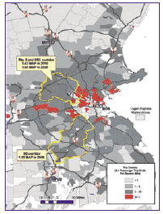

Express Bus Market, 2020
Bradley International Airport
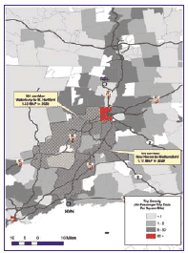

Airport Shared Ride Service

This service is provided by vans offering door-to-door service within a targeted market area with two to five million annual passenger trips. The study indicates that new opportunities for this service are emerging in: Boston Logan International Airport’s market:

- Cambridge/Somerville/
- Arlington/Belmont, and
- Newton/Brookline/Watertown

Providence’s T.F. Green’s market:

- Providence/Cranston/Warwick/Pawtucket

The analyses described in this article have focused upon identifying viable markets in which investments in proven models of public transportation services could be successful, based upon forecast patterns of passenger trips to airports. Since the success of these alternative modes relies upon providing a better combination of price and convenience than private cars, it is conceivable that they could also be designed to help airports reduce leakage from their catchment areas. This could be a productive area to explore in any subsequent studies. On the other hand, based upon current research, public transportation services beyond these identified markets will be very risky for any substantial public investment.

Shared Ride Market, 2020
Logan International Airport
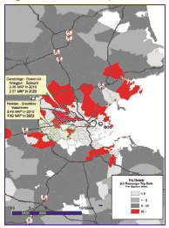

Shared Ride Market, 2020
T.F. Green Airport
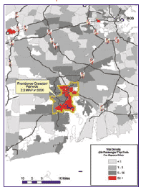

Challenges for the Region’s System of Scheduled Passenger Jet Services

Introduction. As we reflect on the results of the forecasts, as presented in the preceding article, the following questions arise: What have we learned about the main air transportation issues that lie ahead for the New England region and how might they best be approached? In this article we address these questions, drawing on the primary themes of the NERASP study: a strong commitment to developing a New England regional aviation strategy and a focus throughout on acquiring - and applying - an understanding of the long-term interactions involved in regional aviation systems development. These interactions involve consideration of passenger needs, observed travel behavior, how the air carriers respond to market signals, and the lead-time required to accomplish development of major airport facility projects. From all of these considerations we have distilled a set of strategic objectives and associated issues to be pursued.

Looking ahead - potential trend breakers. As shown in the previous article, “Understanding Regional Airport System Dynamics” the development of the regional system has been greatly determined by the continuing evolution and innovation in airline competitive strategies, in response to large-scale forces arising from our economy, society, and aviation technology. In order to develop a strategy that can cope with the risks and uncertainties behind these forecasts, it is useful to speculate about new events that could create major shifts in current trends in air transportation. (See Footnote 11) These include: the price of flying, societal and global issues, advances in aviation technology, and changes in airline business models. These are discussed on the next page.

The price of flying has until recently been in a long-term decline. Reasons for this include improved aircraft technology, airline business practices, and economies of scale associated with a rapidly expanding market. While these forces are predicted to continue to bring reductions in airline yields (fares charged per seat mile), several near-term developments could reverse this trend:

- There is an ongoing discussion of the need to re-structure the user fee system as part of the upcoming Re-authorization of the Federal Aviation Trust Fund. This could create changes in airlines service and pricing strategies as well several components of general aviation activity.
- The volatility of and current high cost of jet fuel has already altered airlines’ decisions on fares and services, especially on longer routes.
- Environmental fees, such as taxes on air quality emissions or the need to purchase emission reduction credits could have dramatic financial implications for air carriers.

Social and global issues can have a major impact in a variety of ways:

- Pandemic outbreaks could significantly dampen passenger activity, perhaps producing severe financial hardship within the airline industry. Growth in terrorism could also lead to dramatic drops in passenger activity.
- Globalization, especially involving the more populous under-developed nations, could expand international travel with New England.
- Immigration patterns may eventually lead to greater air travel demand to new overseas markets.
- The retirement of the baby boomer generation may expand air travel markets. This would include leisure travel and travel generated by a growing trend to retire in countries with a lower cost of living.

Advances in aviation technology usually produce new opportunities for expansion of air travel services. These could include:

- The reliability and safety of air travel can be enhanced through improvements in navigation and surveillance technology, especially by exploiting satellite-based systems and in-cockpit avionics.
- “Micro-jet” technology and other breakthroughs in small aircraft technology may expand the market for point-to-point, on-demand flying. This could erode the ability of scheduled airlines to sell premium fares for first class passengers. It could also require significant enhancements to the air traffic system to expand airspace capacity.

Changes in airline business models to pursue greater efficiencies could include:

- Reductions in operational overhead through greater use of common vendors for terminal services, including ticket processing, baggage handling, and ramp services. This business model would make it easier for airlines to enter smaller markets.
- Expanded use of information technology for “e-ticketing,” reservations, dynamic pricing to achieve higher load factors, re-routing passengers from cancelled flights, integrating reservations for ground transportation services, remote check-in, etc.

Specific challenges to New England’s regional airport system.

The results of the forecasts, along with our growing understanding of the dynamics of the airport system, suggest a variety of challenges to be addressed in order to secure high quality air transportation across New England. These challenges are described below under headings that represent the objectives for addressing them.

Provide airline services close to centers of passenger demand. The forecasts from the airport choice model identify where services can be enhanced to reduce “leakage” from airport catchment areas.

- Even with continuing expansion of regional airport services, the majority of New England passengers will fly through Boston Logan International Airport. Maintaining reliable and efficient airline services at Logan will be critical to how well the system meets the region’s needs for air transportation.
- New Haven has the largest under-served passenger base. Improving service there could reduce the number of travelers on congested highway corridors. Complicating decisions in that direction is the fact that New Haven has the region’s most challenging site problems for airfield and landside facilities.
- Worcester’s catchment area is comparable to Portland’s, yet it has lost service due to general financial problems of the airlines and direct competition from adjacent catchment areas, primarily Providence and Logan. Where New Haven is constrained by facilities, Worcester is constrained by airline industry practices. The forecast models demonstrate that removing airline reluctance to duplicate services could support viable service for almost 1.5 million passengers by 2020.
- Southeast Massachusetts and Cape Cod have a large base of passengers traveling on domestic routes outside of New England. Further analysis can determine the most beneficial way to meet the needs of the growing population and diversifying economy of that area.
- East Asia and India are emerging as key global markets for New England services and are becoming competitive in the areas of new technology research and development. Development of convenient non-stop service to those destinations is a current priority for Logan. This means that the airport must provide a level of service that is competitive with other U.S. international gateway airports. While delays at Logan have declined with the loss of traffic since 2001, this airport is now positioned to grow and will be vulnerable to significant delay problems in IFR weather. (See Footnote 12)
- To support the economic activities of Providence and Manchester, there is a need to develop facilities to support non-stop flights from those cities to the west coast. Airlines have been reluctant to use Manchester's longer runways to accomplish this if they cannot match the service at Providence.

Enhance the reliability of scheduled airline service for all airports in New England.

While periodic delays are tolerable, especially when traveling significant distances, lengthy delays and cancellations can be extremely costly to passengers. If service due to congestion at Logan erodes to the point where passengers frequently experience missed connections or delays, then the “true cost” of air travel from New England may become too high to sustain the region’s competitiveness. Likewise, the ability of smaller airports to support low-weather minimum operations is essential in order to maintain airline services.

This was borne out by the experience of airlines operating out of Worcester in the 1980s when the inability to land and depart in low ceilings and visibility led to frequent schedule
disruptions. Although significant investments have been made to reduce this problem,
a perception remains among a segment of airlines and passengers that the airport is unreliable. To achieve and maintain a reputation of reliable service despite severe weather patterns New England airports must:

- Assess the capability of Boston Logan’s airside and landside facilities in light of these forecasts as well as changes in aircraft fleet mix and airline service strategies.
- Support implementation across the system of next generation (NexGen) navigation and surveillance technology systems currently being developed by FAA.
- Minimize leakage into Logan from the catchment areas of Providence, Manchester, Worcester, and Portland.
- Support continued growth of service at Bangor and Burlington Airports since this is their reliance on Boston for connecting flights.
- Support proper application of dynamic, peak-period management programs when proposed schedules exceed VFR capability as currently adopted by Logan.

Secure the stability of regional airports.
- Encourage a diversity of airlines at all airports in order to minimize risks associated with heavy reliance upon the fortunes of a single airline.
- In weaker markets, identify ways to reduce risks for new entrants and provide incentives for maintaining service over the long term.
- In order to secure and maintain services at smaller rural markets, assure that such airports have facilities that allow airlines to operate efficiently and with reasonable user fees.

Develop “niche” market airports (e.g.,) Bedford and Portsmouth) to enhance system performance and resiliency. These airports have facilities that offer opportunities to enhance passenger services in specialized areas. If these facilities became unavailable for any reason, it would be almost impossible in the future to develop runways with the same proximity to the Boston market. It is therefore essential to the long-term interests of the entire system to preserve these runways. Portsmouth will soon be investigating its potential to accommodate the new family of very large transport jets. It has previously hosted charter flights and this is one of several niches that will be examined in the future.

Improve the relationship of the New England system to adjacent airport markets such as Albany, White Plains, and Newburgh. It is important that investment decisions for New England airports that compete with these New York airports are aware of developments that could impact future passenger levels and revenue forecasts. Likewise it may be relevant to environmental and investment decisions at these New York airports to understand the system benefits they could provide to New England passengers.

Improve ground access to the New England airports.

The portion of air travel that occurs within an aircraft’s cabin is obviously only one component of the trip from the passenger’s point of view. Increasingly, the ease of getting to the door of the airport terminal and the cost of parking or alternative transportation services may be just as influential in planning the trip as the price of the ticket and flight times.
- Airport ground access times have recently changed for Boston with the Third Harbor tunnel dramatically reducing travel times to downtown Boston and communities served by the Massachusetts Turnpike. (See Footnote 13)
- There is a planned new access road to Manchester from Route 3 that will significantly reduce access to communities southwest of Manchester.
- The City of Worcester is working with its regional planning agency to address the need to improve access to Worcester Airport as part of a project to improve east-west transportation for this area. The NERASP airport choice model indicates that, in the Base Case forecast, improvements equivalent to a ten-minute reduction in access time from I-290 could increase Worcester Airport passengers by 110,000, or 39 percent.
- T.F. Green Airport has commenced the development of an Airport Rail Station with an associated parking garage. But in order to be of value to airport passengers, rail service must provide sufficient frequency and hours of service for air traveler requirements.
- New models of ground access services should be explored for their ability to improve the ability of regional airports to increase their share of passengers.
- Integrating express bus service to Logan and Providence at the Route 128 Railroad Station would offer passengers a variety of appealing itinerary options that could include combining airports or even modes.
- Use of information technology and other technology could help optimize coordination of door-to-door services to improve their efficiency.
- Manchester is experimenting with free bus service to the Woburn transportation center and a mass transit station in Somerville.

Improve the environmental review process.

Airports are obviously a conspicuous component of a community’s landscape. In addition to the travel benefits they create, they can also generate off-site impacts such as traffic, noise, and air quality. Conflicts arising from the proximity of airports to communities has in the past given rise to complex and lengthy environmental review processes. This has occurred even when off-site impacts are relatively modest. Sometimes environmental reviews are so lengthy that the original impacts under investigation are reduced by virtue of the inevitable advances in aviation technology and operating practices. This can affect the original objectives concerning purpose and need as well as the accuracy of projected impacts under conditions of altered fleet mix and activity levels.

Emerging Market

By 2020, the Cape Cod market will have grown to almost two million flying to destinations beyond New England and the NYC area. This reflects the Cape’s evolution from primarily a seasonal vacation/retirement community to a more balanced year-round economy. Because the closest airport for long trips is Logan, most of these passengers will be driving along the congested Route 3 corridor or traveling west to Providence.

The primary airport serving Cape Cod is Barnstable Municipal Airport with intra-regional service to the islands, Boston, and the NYC area. Its longest runway is 5,425 feet, and its expansion is constrained by major arterial roads, substantial development, and natural resources. It has never been evaluated for providing services beyond the Boston and New York City markets.

In order to address these concerns there is a need to:
- Build acceptance for the regional airport strategy to enhance the capacity of each airport to provide reliable and efficient airport services for its market area.
- Develop - and communicate - an understanding of purpose and need focused on long-term public interest versus a specific airline’s immediate needs.
- Apply the principles of FAA’s guidance for streamlining through early integration of the environmental review process in planning.
- Use scenario forecasts or principles of risk analysis to provide forecasts of impacts that cover the range of uncertainty involved in predicting levels and types of aviation activity.

Alternative modes to air travel.

This study team reviewed current analysis of AMTRAK service conducted by the Volpe National Transportation System Center. It was determined that high-speed rail is a valuable complement to the region’s air service system. Each mode offers advantages that depend on the details of the journey and the needs of the traveler. At the same time, future enhancements to high speed rail service appear less likely to impact airport facility planning than air carrier decisions concerning schedules, fares and aircraft size. Improved ground access between Manhattan and the New York City airports may also reduce the relative advantage of rail for city center to city center trips.

There’s always something new!

One of the exciting aspects of being involved in air transportation is that it is constantly changing. Therefore, while the strategies discussed in this document are based upon a 2020 forecast, the most reliable prediction is that these strategies must evolve and adapt to the ever-changing nature of passenger needs, airline innovations, and our improved understanding of their interactive relationships. This will require ongoing review of market conditions as well as updates to this plan based upon the variety of setbacks and new opportunities that are bound to present themselves through the future. Given what this coalition has accomplished in the past ten years, continuing this collaboration through the next decade promises to be a very rewarding investment of effort for securing the region’s air transportation needs.

While the system can continue to serve this area from Boston and Providence, the size of this market means that there is also an opportunity to improve air transportation services for the needs of the industries and population on the Cape. Over the long term it also represents another opportunity to reduce congestion going into Boston. Identifying the variety of alternatives to accomplish this and how they would relate to ongoing growth management planning for the future of Cape Cod could be a very timely and valuable initiative.
Bangor International Airport

Bangor International Airport (BGR) is a public use airport located three miles west of the City of Bangor in Penobscot County, Maine.

New Non-stop Service Opportunities
- Short/Medium Haul Connection Hubs
- Short Haul High Density

Future Capital Improvements
- Terminal study
- Construction of access road
- Design of parking structure
- Stormwater plan update

Historical Total Passenger Levels

Year | Passengers
2005 | 480,605
2004 | 453,301
2003 | 408,264
2002 | 408,546
2001 | 369,607
2000 | 382,565

BGR Airport Usage by Ground Origin Destination, 2004
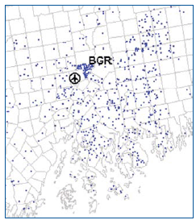
 = 500 Trip Passengers
Airport Information
- 2,079 acres
- Runway 15-33: 11,439’ long
- 8 Aircraft Gates
- Served by 5 airlines
- 7 non-stop destinations

Catchments Area Forecast Underlying Socioeconomics
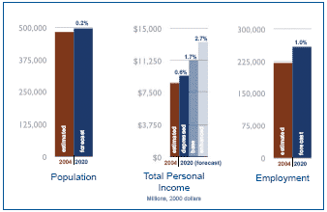
Percentages represent average annual growth

Forecast Airport Passengers and Service Levels
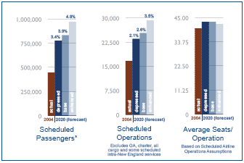
Percentages represent average annual growth
* Actual data is for year ending July 2004 and may not coincide with annual historical passengers (calendar year) presented on preceding page.

Functional Role

Bangor has served in a niche role as a refueling stop for flights to Florida and other domestic markets as well as for clearing customs for international flights. Bangor also plays an important role in providing access to tourists visiting the state, providing air service to northeastern and central Maine.

Current Concerns

Bangor International Airport must position itself to meet the challenges presented by restructured airline fleets, new airline business aviation, in addition to increased regulatory requirements and increasing energy costs.

Outlook

Bangor International Airport has tremendous resources in its extensive infrastructure, available land and highly qualified personnel. These factors combine to make Bangor International Airport an attractive place to conduct business. The airport will also continue to seek out niche opportunities and businesses that complement its existing services.
Boston Logan International Airport

Boston Logan International Airport (BOS) is a public use airport located in the East Boston neighborhood of Boston, Massachusetts.

New Non-stop Service Opportunities
- Small Transcontinental
- Medium Haul Regional Jet
- International

Future Capital Improvement
- Commuter runway under construction
- Centerfield taxiway improvements

Historical Total Passenger Levels

Year | Passengers
2005 | 27,087,905
2004 | 26,142,516
2003 | 22,791,169
2002 | 22,696,141
2001 | 24,474,930
2000 | 27,726,8333

BOS Airport Usage by Ground Origin Destination, 2004

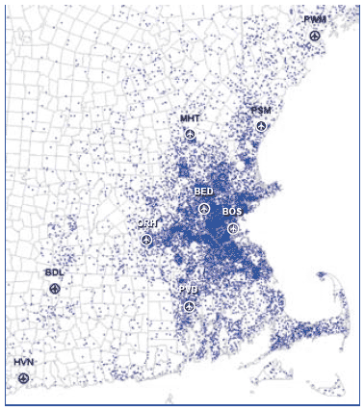
 = 1,000 Trip Passengers

Airport Information
- 2,400 acres
- Runway 15R-33L: 10,083’ long
- Runway 4R-22L: 10,005’ long
- Runway 9-27: 7,000’ long
- Runway 15L-33R: 2,557’ long
- 102 Aircraft Gates
- Served by 45 airlines (16 foreign)
- 76 non-stop destinations (33 int’l)

Catchment Area Forecast Underlying Socioeconomics
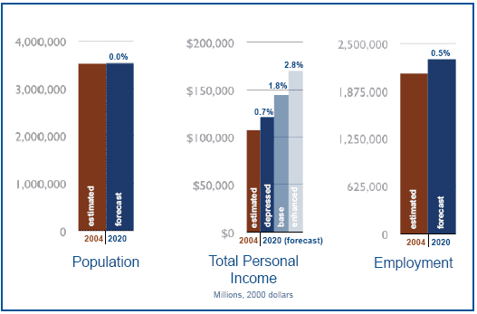
Percentages represent average annual growth

Forecast Airport Passengers and Service Levels
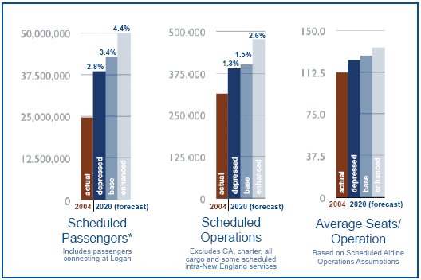
Percentages represent average annual growth
* Actual data is for year ending July 2004 and may not coincide with annual historical passengers (calendar year) presented on preceding page.

Functional Role

Logan will continue to serve as the premier commercial airport for New England. Its most critical role is providing an efficient connection between New England and the global economy. It will continue to dominate consumer choice for long distance markets as well as the high frequency shuttle and Northeast Corridor markets (particularly NYC and Washington, D.C.). And Logan will provide the essential link between the national air transportation system and New England destinations, such as Cape Cod and the Islands and some of the region’s rural areas. Logan service to northeast corridor markets will be complemented, by continued improvements to high speed rail service to those markets.

Current Concerns

Logan lost considerable passenger activity and airline services following the terrorist attacks of September 11, 2001. It haws since developed a competitive low fare structure that has helped rebuild its passenger volumes. However, it lacks non-stop service to certain key Asian destinations, now a high priority for Massport.

As Logan continues its transition to an almost all-jet fleet, airfield arrival and departure capacity will be reduced somewhat. In terms of effective passenger capacity, this will, to some extent, be offset by growth in cabin size (seats/operation).

Outlook

Logan should continue to pursue new air traffic control technology to improve efficiency, especially during adverse weather conditions. As demand for air travel increases, Logan and the regional airports must continue to expand service opportunities. It is especially important that Logan provide for international service demand.
Bradley International Airport

Bradley International Airport (BDL) is a public use airport located thirteen miles north of Hartford, the capitol of Connecticut, and just sound of Springfield, Massachusetts.

New Non-stop Service Opportunities
- Large Transcon
- Medium Haul RJ
- Long Haul Connection Hubs
- Short Haul RJ
- Florida Markets

Future Capital Improvements
- Relocation of taxi and hold line for RW 1
- Rehabilitiation of portions of TW E and T
- RW 33 Precisions Approach Path Indicator Installation
- Phasing study for terminal expansion
- Master Plan Update
- Purchase of nosie monitoring equipment
- Implementation of noise plan

Historical Total Passenger Levels
Year | Passengers
2005 | 7,381,372
2004 | 6,737,048
2003 | 6,261,807
2002 | 6,525,215
2001 | 6,888,031
2000 | 7,338,744

BDL Airport Usage by Ground Origin Destination, 2004
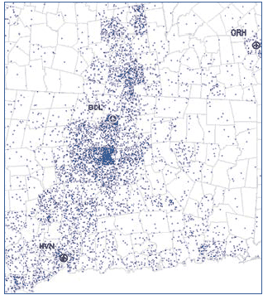
 = 1,000 Trip Passengers

Airport Information
- 2,616 acres
- Runway 6-24: 9,502’ long
- Runway 15-33: 6,846’ long
- Runway 1-19: 5,141’ long
- 30 Aircraft Gates
- Served by 13 airlines
- 36 non-stop destinations

Catchment Area Forecast Underlying Socioeconomics
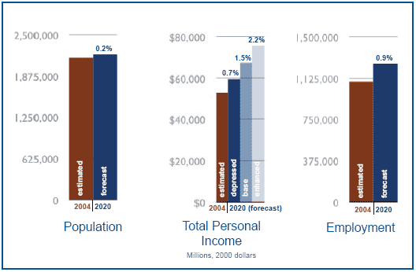
Percentages represent average annual growth

Forecast Airport Passengers and Service Levels
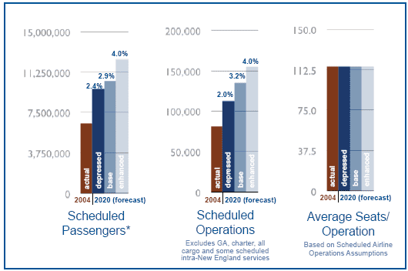
Percentages represent average annual growth
* Actual data is for year ending July 2004 and may not coincide with annual historical passengers (calendar year) presented on preceding page.

Functional Role

Bradley will continue to hold its position as the second largest airport in New England, expeceted to reach a voum of 10 million passengers by 2020. Bradley’s current service market supports long haul flights to the West Coast including Los Angeles, Salt Lake City and Las Vegas on a dailyl basis. Aggressive route development strategies are in place to address the growing need for non-stop trans-Atlantic service and additional West Coast service.

Currently, over 30 percent of Bradly passengers originate from the New Haven catchment area with 12 percent fromt eh catchment areas of Worcester, Providence and elsewhere in New England. Fairfield County, in the southern end of the state, continues to show increased patron usage.

Current Concern

Airport access may develop as an issue depending upon how certain local highway conditions are addressed.

Outlook

Bradley is well positioned to continue its development to serve the needs of the second largest market in New England.
Burlington International Airport

Burlington International Airport (BTV) is a public use airport located three miles east of Burlington, Vermone, within the City of South Burlington, Vermont.

New Non-stop Service Opportunities
- Short/Medium Haul Connections Hubs
- Florida Markets

Future Capital Improvements
- New aprons and taxiways on south end
- Possible extension of TW G
- North air carrier parkign apron expansion
- Norht terminal expansion
- Noise exposure map update
- Glycol collection and treatment system

Historical Total Passenger Levels
Year | Passengers
2005 | 1,371,534
2004 | 1,266,999
2003 | 1,097,174
2002 | 1,099,100
2001 | 1,035,238
2000 | 904,582

BTV Airport Usage by Ground Origin Destination, 2004
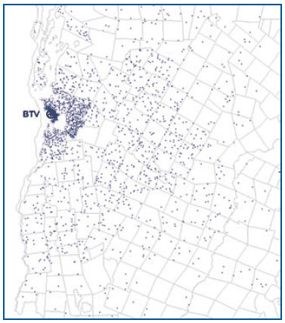
 = 500 Trip Passengers

Airport Information
- 942 acres
- Runway 15-33: 8.320’ long
- Runway 1-19: 3,611’ long
- 10 Aircraft Gates
- Served by 6 airlines
- 13 non-stop destinations

Catchment Area Forecast Underlying Socioeconomics
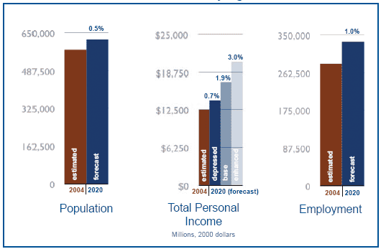
Percentages represent average annual growth

Forecast Airport Passengers and Service Levels
Percentages represent average annual growth
* Actual data is for year ending July 2004 and may not coincide with annual historical passengers (calendar year) presented on preceding page.

Functional Role

With little competition from other system aiports, Burlington’s role has been the provision of service to a comparatively large and fairly remote northwest New England catchment area.

Current Concerns

Because of Burlington’s remoteness from other airports, the catchment area that it serves is very dependent upon this airport to provide for their air transportation needs.

Local planning and investment is needed to ensure that facilities provide carriers with both the flexibility, reliability, and efficiency that is needed to retain current service and to foster the continued development of appropriate services.

Outlook

The introduction of service by a low fare carrier has been very successful. Growth that is associated with this will allow access to additional national hubs as well as direct flights to more Florida markets.

L.G. Hansom Field

L.G. Hanscom Field (BED) is a public use airport located in Bedford, Massachusetts, just 20 miles northwest of the City of Boston.

New Non-stop Service Opportunities
- Short/Medium Haul Connection Hubs
- Short Haul High Density

Future Capital Improvements
- Airport Layout Plan update ongoing
- New General Aviaition facilities at Pine Hill
- Redevelopment of Hangar 24 Site
- Potential relocation of T-hangars
- New General Aviation facilities at the Civil Terminal Area
- Redevelopment of Hangar 10 site
- Runway Safety Area Enhancements

Historical Total Passenger Levels
Year | Passengers
2005 | 17,457
2004 | 18,123
2003 | 36,099
2002 | 67,688
2001 | 134,337
2000 | 162,147

BED Airport Usage by Ground Origin Destination, 2004
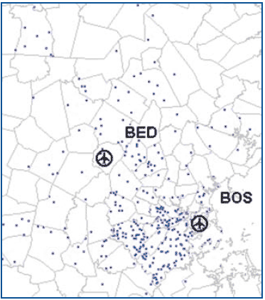
 = 500 Trip Passengers

Airport Information
- 1,300 acres
- Runway 11-29: 7,000’ long
- Runway 5-23: 5,106’ long
- Limited scheduled airline service

Catchment Area Forecast Underlying Socioeconomics
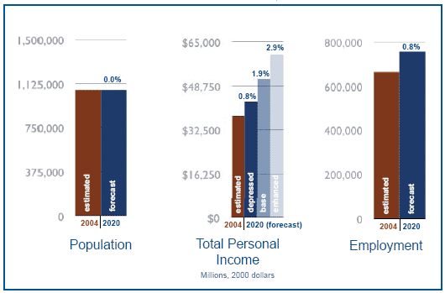
Percentages represent average annual growth

Forecast Airport Passengers and Service Levels
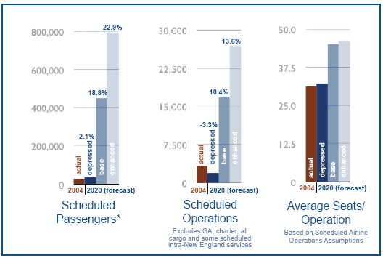
Percentages represent average annual growth
* Actual data is for year ending July 2004 and may not coincide with annual historical passengers (calendar year) presented on preceding page.

Functional Role

L. G. Hanscom Field is New England’s premier full-service general aviatioin (GA) airport, functioning as a general aviation reliever for Logan International Airport. Hanscom handles limited commercial airline and cargo service and is an important resource for Hanscom Air Force Base. Hansom serves the diverse flying needs of the region’s high technology corporations and educational institutions. The GA component includes business, charter, personal aircraft, air taxi and flight school activity. Commercial passenger service is defined as aircraft with no more than 60 seats, per Massport’s regulations.

Current Concerns

In recent years, Hanscom has experienced declines in all types of air trffic except business jets. The small aircraft operators are particularly sensitive to escalating fuel prices. Hanscom’s commuter activity has declined from 160,000 passengers in 2000 to 17,500 today.

Many Hanscom Field facilities were constructed in the 1940s and 1950s and need to be updated. Massport continues to promote third party development of hangar facilities and other infrastructure improvements.

Outlook

Hanscom will continue to be a GA reliever for Logan International Airport, supporting a wide range of aviation needs. Its excellent airfield and aviation services are widely recognized, and Massport must continue to capitalize on those elements. Third party developers continue to show interest in Hanscom, indicating a positive future.
Manchester Boston Regional Airport

Manchester Boston Regional Airport (MHT) is located in southeastern New Hampshire, approximately 50 miles from Boston, Massachusetts.

New Non-stop Service Opportunities
- Large Transcontinental
- Medium Haul Regional Jet
- Long Haul Connection Hubs
- Florida Markets
- International

Future Capital Improvements
- Runway Safety Area Improvement Underway
- New Master Plan Study
- Additional Terminal Gates
- Airport Access Roadway Improvements
- Future Parking Garage

Historical Total Passenger Levels
Year | Passengers
2005 | 4,329,478
2004 | 4,003,307
2003 | 3,601,661
2002 | 3,366,834
2001 | 3,233,555
2000 | 3,169,301

MHT Airport Usage by Ground Origin Destination, 2004
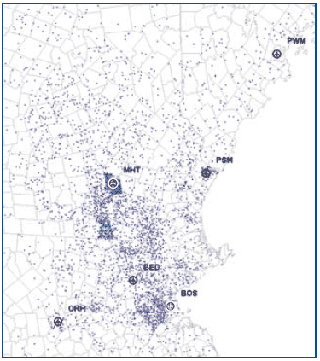
 = 1,000 Trip Passengers

Airport Information
- 1,500 acres
- Runway 17-35: 9,250’ long
- Runway 6-24: 6,850’ long
- 14 Aircraft Gates
- Served by 12 airlines
- 17 non-stop destinations

Catchment Area Forecast Underlying Socioeconomics
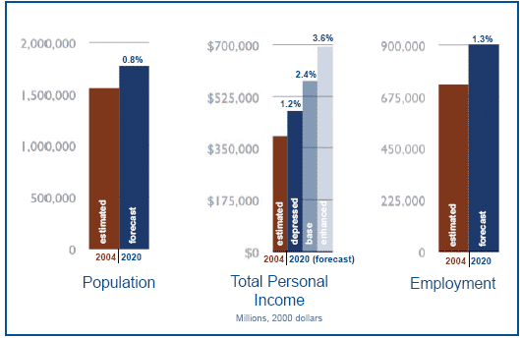
Percentages represent average annual growth

Forecast Airport Passengers and Service Levels
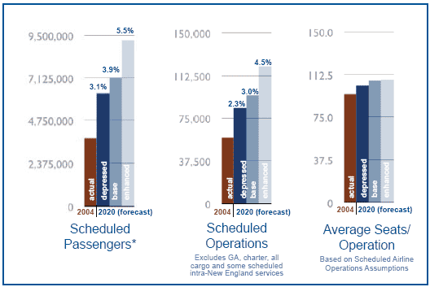
Percentages represent average annual growth
* Actual data is for year ending July 2004 and may not coincide with annual historical passengers (calendar year) presented on preceding page.

Functional Role

Manchester Boston Regional Airport will continue to serve its primary market as well as relieve passenger demand pressure on Logan from areas to the north and west of Boston. In the recent past, new routes met with quick success, as indicated by load factors sustained over time.

Current Concerns

At Manchester, a dominant low fare carrier heavily influences service levels, in terms of schedule and fare structure. However, it is expected that this will modearate as the market continues to develop, with entry into the market by other carriers emplyin gthe low fare business model.

Outlook

With completion of the major runway extensions and related airfield improvements, Manchesterd is wll-positioned to offer airlines an efficient facility for responding to the needs of the fastest frowing market area of the rgion. This includes the capability to privide nonstop serice to the West Coast and to select North American and North Atlantic international markets. Future planning will focus on developing the landside and airport access facilities and services to support the expanding requirements of its passengers.

Manchester will continue to be a valuable and necessary asset in New England, providing needed air transportation services for its established market while serving as a reliever to Logan as passenger demand continues to increase in the future.
Portland International Jetport

Portland International Jetport (PWM) is a public use airport located two miles west of Portland, in Cumberland County, Maine.

New Non-stop Service Opportunities
- Large Transcontinental
- Medium Haul Regional Jet
- Long Haul Connections Hubs
- Short Haul Regional Jet
- Florida Markets

Future Capital Improvements
- Runway extension/overlay project for RW 18/36
- Rebuild taxiways associated with RW 18/36
- Parking garage expansion
- Terminal expansion
- Inline baggage screening
- New general aviation area

Historical Total Passenger Levels
Year | Passengers
2005 | 1,454,037
2004 | 1,365,078
2003 | 1,248,972
2002 | 1,248,362
2001 | 1,252,597
2000 | 1,342,557

PWM Airport Usage by Ground Origin Destination, 2004
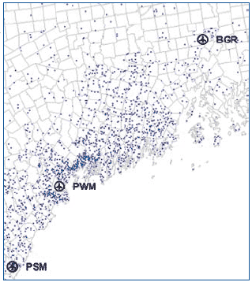
 = 500 Trip Passengers

Airport Information
- 636 acres
- Runway 11-29: 7,200’ long
- Runway 18-36: 5,001’ long
- 11 Aircraft Gates
- Served by 6 airlines
- 11 non-stop destinations

Catchment Area Forecast Underlying Socioeconomics
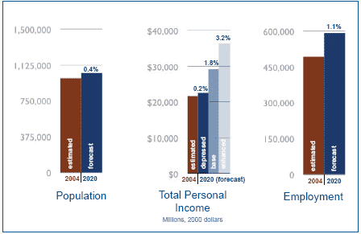
Percentages represent average annual growth

Forecast Airport Passengers and Service Levels
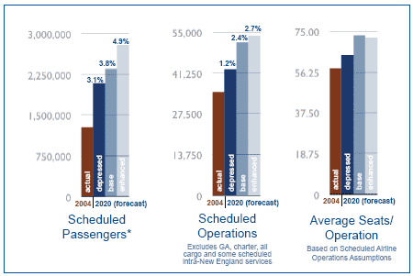
Percentages represent average annual growth
* Actual data is for year ending July 2004 and may not coincide with annual historical passengers (calendar year) presented on preceding page.

Functional Role

Portland serves as an area of strong economic growth, with recent rates of population increase that are several times as high as the state as a whole. Recent improvements in highway access have improved its appeal to passengers within its catchment area. Portland plays an important role in providing access to tourists visiting the state.

Current Concerns

Portland has historically experienced significant leakage to Boston and, to a lesser extent, Manchester. For example, in 2004, 41 percent of its catchment area enplanements were attracted to Boston, as compared to the 40 percent that used Portland.

Expansion of flightts must be monitored to minimize noise impacts to residents.

Outlook

Portland does not appear to face any insurmountable challenges in meeting the needs of their communities.

The impact of leakage from Portland to Boston could potentially be softened by the introduction of low fare carrier service to the JFK hub.
Portsmouth International Airport

Portsmough International Airport (PSM) is a public use airport located in Portsmough in the southeastern part of New Hampshire, about 50 miles north of Boston, Massachusetts.

New Non-stop Opportunities
- Florida Markets

Future Capital Improvements
- Regional supplemental study
- Viability study of Very Large Aircraft (VLA)
- Roadway access and frontage drive improvements

Historical Total Passenger Levels
Year | Passengers
2005 | 13,114
2004 | 54,868
2003 | 58,706
2002 | 67,718
2001 | 72,980
2000 | 78,076

New England Passengers
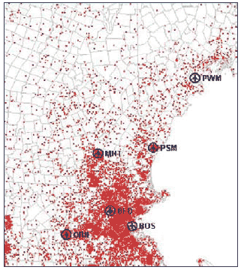
 = 2,500 Trip Passengers

Airport Information
- 3,000 acres
- Runway 16-34: 11,318’ long
- 1 Aircraft Gate
- Served by 2 airlines
- 2 non-stop destinations

Catchment Area Forecast Underlying Socioeconomics
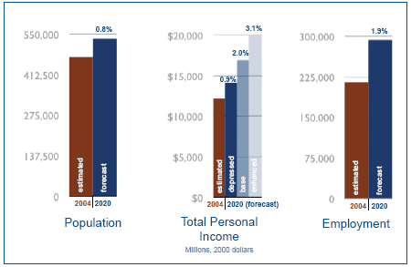
Percentages represent average annual growth

Forecast Airport Passengers and Service Levels
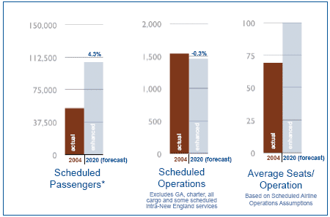
Percentages represent average annual growth
* Actual data is for year ending July 2004 and may not coincide with annual historical passengers (calendar year) presented on preceding page.
** depressed and base data not available for this airport.

Functional Role

Portsmough has the system’s longest runway and can easily accommodate the new Airbus A380 aircraft. It also has a twenty-four hour tower. Index E, ARFF services, and on-site custom services.

Since its opening as a civilian base, it has provided the airline industry with facilities for a wide variey of users. These have included a maintenance operation for a regional commuter airline, air cargo ooperations, air charer flights, and new entrant airlines. Its fixed base ooperators have developed services meeting the full range of ground handlling services for scheduled air carriers, international business jets, and charter flights.

The airport has also enabled the Air National Guard to provide critical support in airborne refueling of both traiing and actual military missions.

Current Concerns

The proximity of the airport to major population centers to the south, north, and west supports the potential of this airport to be an important supplement to the regional system. On the other hand, this restricts air service development to niche markets not served by the existing surrounding airports.

Outlook

Portsmough is well positioined to provide very efficient facilties for air charters serving the northern portion of the Boston market. It is currently using the data from this study to further identify niche market opportunities.
T.F. Green Airport

T.F. Green Airport (PVD) is a primary service airport located in Warwick, Rhode Island, eleven miles south of Providence, in Kent County, Rhode Island.

New Non-stop Service Opportunities
- Large Transcontinental
- Medium Haul Regional Jet
- Long Haul Connection Hubs
- Florida Markets
- International

Draft Airport Master Plan Recommendations
- Improve Runway Safety Areas for RW 16-34
- Extend RW 5-23
- Improve various taxiways
- Improve terminal security
- Improve terminal area baggage facilties
- Add gates to terminal (couth concourse)
- Expand auto parking
- Improve terminal access roadway from Post Road
- Expand Central Utility Plant
- Expand ARFF building
- Construct replacement GSE building
- Construct replacement belly cargo facility
- Construct new integrated cargo facility
- Improve glycol management facilities

Historical Total Passenger Levels
Year | Passengers
2005 | 5,730,557
2004 | 5,509,186
2003 | 5,176,271
2002 | 5,393,574
2001 | 5,530,393
2000 | 5,430,938

PVD Airport Usage by Ground Origin Destination, 2004
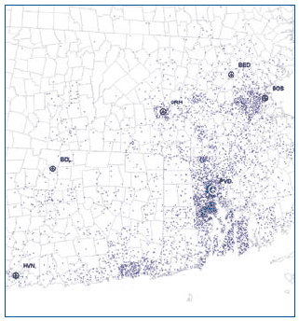
 = 1,000 Trip Passengers

Airport Information
- 1,111 acres
- Runway 5-23: 7,166’ long
- Runway 16-34: 6,081’ long
- 21 Aircraft Gates
- Served by 11 airlines
- 28 non-stop destinations

Catchment Area Forecast Underlying Socioeconomics
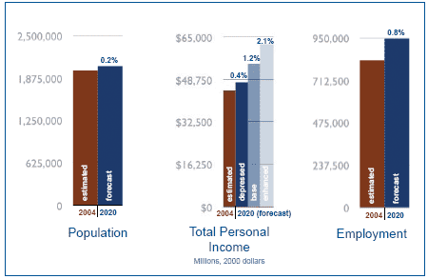
Percentages represent average annual growth

Forecast Airport Passengers and Service Levels
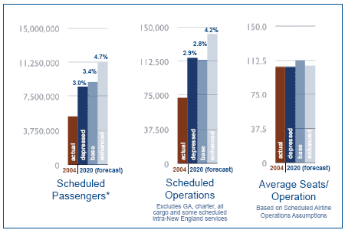
Percentages represent average annual growth
* Actual data is for year ending July 2004 and may not coincide with annual historical passengers (calendar year) presented on preceding page.

Functional Role
T.F. Green Airport will continue to serve the Rhode Island market as well as air travelers in eastern Connecticut and southeastern Massachusetts. In the recent past, new routes met with quick success, as indicated by load factors sustained over time.

Current Concerns

To increase the service market opportunties and operating flexibility for all carriers serving T.F. Green, and Environemntal Impact Statement is being prepared to evaluate the impacts of a runway extension and terminal improvements identified in the Draft Airport Master Plan.

At T.F. Green, a dominant low fare carrier heavilly influences service levels, in terms of schedule and fare structure. However, it is expected that this will moderate as the market continues to develop, with entry into the market by other carriers employing the low fare business model.

Outlook

The Providence market is approaching the size that could support non-stop service to the West Coast and select destinations in Canada, t he Caribbena, and North Atlantic Europe.

T.F. Green is located at a major nexus of transportation services for southern New England, including the aiport rail statioin now under construction. Current environmental studies will affect the capability of the airport to meet current and future requirements of the population and economy of this area. If approved, planned runway extensioins and related mitigation will requrie significant invenstments. The costs of these projects are justified byt eh contribution this airport makes to the functioning of the regional system.
Tweed–New Haven Regional Airport

Tweed-New Haven Regional Airport (HVN) is a public use airport located in the City of New Haven and the Town of East Haven, Connecticut.

New Non-stop Service Opportunities (When Faciltiy Improvements Permit)

Within five years:
- Runway Safety Areas on RW 2/20
- MALSR for RW 2
- Relocate threshold on RW 20
- Improved approach to RW 20
- Centerline/Touchdown Zone lights for RW 2/20

Within twelve years:
- Pave Runway Safety Areas
- Add 600 feet to RW 2/20
- Category II Infrastructure for RW 2
- Approached Lighting System (ALSF-2) for RW 2

Historical Total Passenger Levels
Year | Passengers
2005 | 130,861
2004 | 80,356
2003 | 33,607
2002 | 44,487
2001 | 57,614
2000 | 76,726

New England Passengers
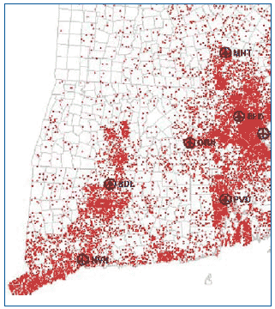
 = 2,500 Trip Passengers

Airport Information
- 394 acres
- Runway 02-20: 5,600’ long
- Runway 14-32: 3,175’ long
- 4 Aircraft Gates/1 with Jetbridge
- Served by 1 airline
- 1 non-stop destination

Catchment Area Forecast Underlying Socioeconomics
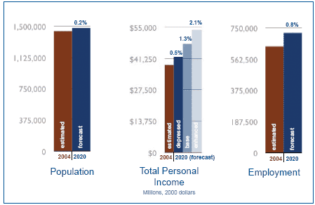
Percentages represent average annual growth

Forecast Airport Passengers and Service Levels
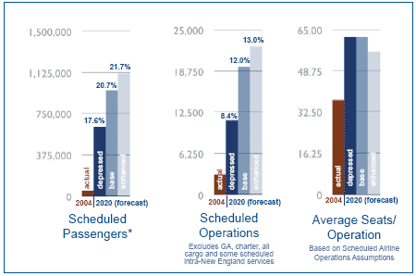
Percentages represent average annual growth
* Actual data is for year ending July 2004 and may not coincide with annual historical passengers (calendar year) presented on preceding page.

Functional Role

Despite its catchment area of 2.8 million passengers, the fifth largest in New England, only one percent of that catchment area used New Haven in FY 2004, 59 percent used Bradley, 23 percent used the New York City area airports, and 13 percent used Providence.

Current Concerns

Tweed is now being viewed as a vital component in a statewide system of airports to serve the flying public: Bradley, as a medium hub international airport for a wide region of New England, and Tweed, as a small hub regional airport for Southern Connecticut. This vision needs to be channeled into supoprt for implementation of the Tweed Master Plan.

Outlook

By 2010, with active support of state and local governments, the Master Plan Update Phases Once and Two will be implemented. The airport will infuse over $75 million annually into the regional economy.

By 2013, based on public demand for more air service, Tweed will successfully implement Master Plan Update Phase Three. The airport will infuse up to $300 million annually into the regional economy.

By 2018, having successfully completed Phase Four of its Master Plan Update, the airport will infuse up to $750 million annually into the regional economy.
Worcester Regional Aiport

Worcester Regional Airport (ORH) provides general aviation and commercial air services tot eh Greater Worcester Area in central Massachusetts. The airport is owned byt eh City of Worcester and operated by teh Massachusetts Port Authority (Massport).

New Non-stop Service Opportunties
- Short/Medium Haul Business and Leisure Connections
- Florida and other niche markets

Future Capital Improvements
- Ongoing airport master plan
- Airfield pavement rehabilitation
- Enhancement to all Runway Safety Areas
- Potential CAT I ILS to CAT II/III upgrade
- Construction of new Airport Rescue & Firefighting Facility
- Construction of new airfield maintenance structure
- New hangar and general aviation service facilities

Historical Total Passenger Levels
Year | Passengers
2005 | 1,729
2004 | 787
2003 | 3,593
2002 | 66,319
2001 | 129,780
2000 | 106,142

New England Passengers
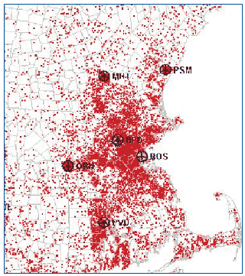
 = 2,500 Trip Passengers

Airport Information
- 1,300 acres
- Runway 11-29: 7,000’ long
- Runway 15-33: 5,000’ long
- 4 Aircraft Gates, 2 Ramp Level Gates

Catchment Area Forecast Underlying Socioeconomics
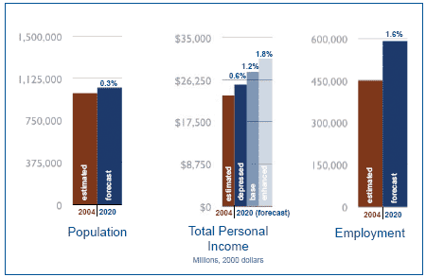
Percentages represent average annual growth

Forecast Airport Passengers and Service Levels
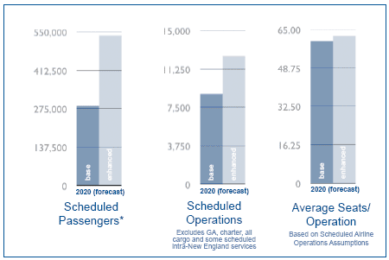
Percentages represent average annual growth
* Actual data is for year ending July 2004 and may not coincide with annual historical passengers (calendar year) presented on preceding page.
** Actual numbers were not available. Worcester did not have scheduled air service in 2004.

Functional Role

Worcester Regional Airport provides general aviation (GA) and commercial aviation service to the Central Massachusetts Region.

Current Concerns

The events of September 11, 2001 significantly affected commercial air service at the airport, resulting in a loss of airlines service by 2003. A low cost carrier providing service to Orlando/Sanford Florida reinstated commercial air service for a shourt period between December 2005 and August 2006. The airport continues to aggressively pursue other commercial aviation service opportunities in the challenging post 9/11 environment. To enhance the security, safety and operational efficiency, essential aviation infrastructure should be maintained and imporved including the rehabilitation of aging runway and taxiway pavements, installatioin of FAA comliant Runway Safety Areas (RSA) on Runway 11-29, upgrade of Category I Precision Approach to Category II/III standards and an aircraft hold apron on the Runway 11 end. Major non-aviation projects that would benefit the airport and the region include improved roadway access, additional signage and roadway infrastructure improvements.

Outlook

The FAA/MAC funded Airport Master Plan (expected to be completed by late 2006) provides a strategic roadmap for the future development of the airport as current and forecasted demand contues through the tewenty-year planning period. Continued community support for the airport, couopled with ongoing marketing strategies for additional scheduled air service and attracting additional-based corporate aircreaft and aviatioin related services are key to the airport’s future growth over the short and long term.
Finally…

This strategy for enhancing the regional airport system has many detailed recommendations. The overall vision, though, is relatively simple. By continuing to enhance the operation of each airport in the system, the region can avoid the tremendous cost and community disruption that developing a new major airport would require. The great challenge is having a solution that is built upon the collective benefit of comparatively smaller scale developments throughout the system. In the face of local controversy that any of these projects may encounter, it will be difficult to appreciate just how dependent the future of the region’s system is on each of these decisions.

Consequently, the primary purpose of this report is to disseminate the essential facts and arguments that can foster a common vision of the critical value of these facility investments. In turn, it is important that this regional strategy continues to be enhanced by the experiences of the participants in this coalition and through periodic updates to the data and models in this study. This is the commitment required to ensure that the region’s future passenger air service system continues to have the ability to help New England be New England.

Acknowledgements

Project Sponsor
The Massachusetts Port Authority (MPA)
Massachusetts Aeronautics Commission (MAC)

Project Consulting Team
The Louis Berger Group, Inc.
in association with:
- SH&E, Inc.
- Unisys/R2A, Inc.
- Charles River Associates, Inc.
- A. Strauss-Wieder, Inc.
- Howard/Stein-Hudson Associates
- Claire Barrett Associates
- MarketSense
- Planners Collaborative - Layout and Design
- The New England Council
- Volpe National Transportation Center

Peer Review Team
- Richard DeNeufville, Massachusetts Institute of Technology
- Tony Gomez-Ibanez, Harvard University
- Steven Morrison, Northeastern University
- Joseph Sussman, Massachusetts Institute of Technology

The Consulting Team would like to express its appreciation to the staff of the Federal Aviation Administration, Massachusetts Port Authority, Mass Aeronautics Commission, the States and Airports in this project for their assistance and support.

Project Funding

The preparation of this study was financed in part through a planning grant from the Federal Aviation Administration with the local matching share of the grant provided by the Massachusetts Port Authority.

Study Team

Federal Aviation Administration – New England Region
- Ralph Nicosia-Rusin, Bryon Rakoff, and Priscilla Scott
Massachusetts Port Authority
- Betty Desrosiers, Craig Leiner, Stewart Dalzell, and Wes Harper
Massachusetts Aeronautics Commission
- COL (Ret.) Robert E. Welch Jr., Denise Garcia, and Scott MacLeod
Stephen Korta, II, A.A.E., State of Connecticut
Ronald Roy, State of Maine
Jack Ferns, State of New Hampshire
Mark Brewer, A.A.E., Rhode Island Airport Corporation
Richard Turner, State of Vermont
Rebecca Hupp, A.A.E., Bangor International Airport
Barry Pallanck, Bradley International Airport
Brian Searles, Burlington International Airport
J. Brian O’Neill, Manchester•Boston Regional Airport
Kevin Dillon, A.A.E., Manchester•Boston Regional Airport
K. William Hopper, A.A.E., Portsmouth International Airport at Pease
Jeff Schultes, A.A.E., Portland International Jetport
Michael Mini, Providence-T.F. Green Airport
Vince Scarano, Providence-T.F. Green Airport
Eliot Jameson, Tweed-New Haven Regional Airport
Rick Lamport, Tweed-New Haven Regional Airport
Eric Waldron, A.A.E., Worcester Regional Airport

With fond memory of consultant team member, Claire Barrett
To obtain a CD of the Study’s Technical Reports, please write to the:

Federal Aviation Administration
New England Region, ANE-600
Attention: NERASP Technical Report CD Request
12 New England Executive Park
Burlington, MA 01803

